#### [Deleted file](http://timisoaractf.ro/challenge?id=10) (100pts)

The challlenge gave us a disk image, and in the description it said something about a deleted file, so running autopsy on it might be helpful

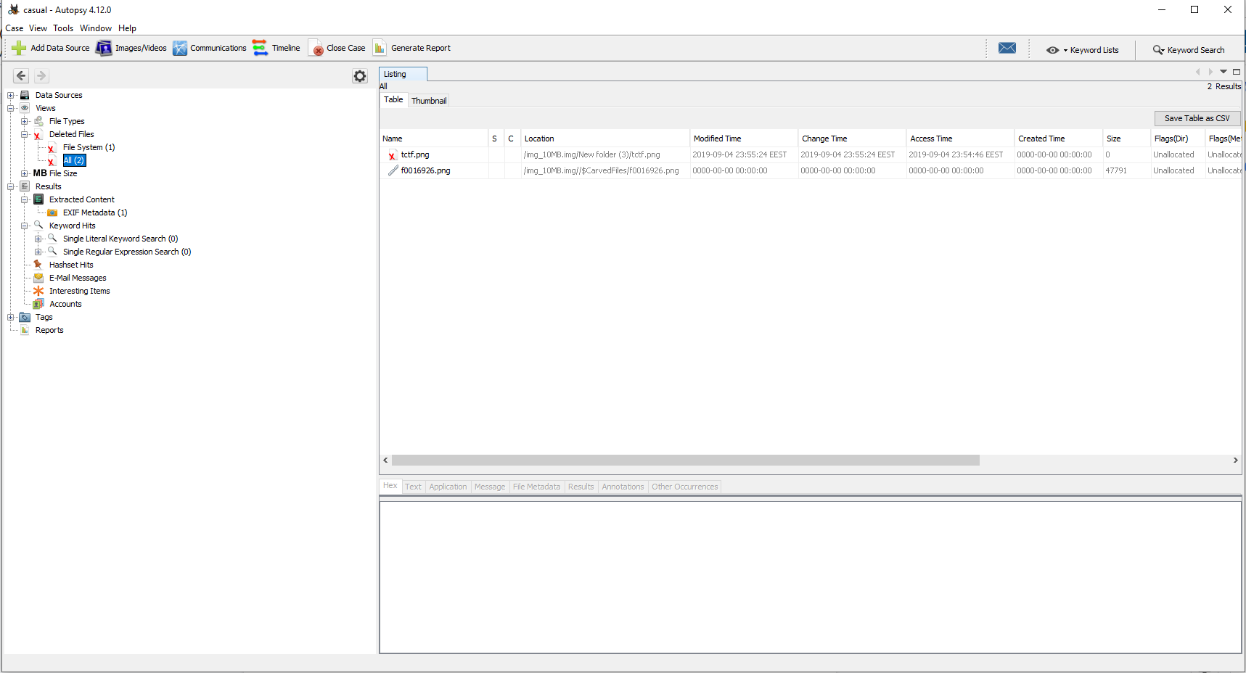

We can indeed see that there are 2 deleted files, out of which only one has a size greater than 0.

Recovering that file we get the following image with the flag:

